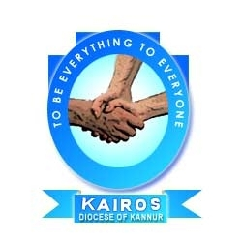
KAIROS KANNUR
ANNUAL REPORT 2018-19

CONTENTS
- INTRODUCTION ABOUT KAIROS
- FAMILY DEVELOPMENT PROGRAMME (FDP)
- KOLPING
- CARITAS INDIA PROJECTS
- ASHAKIRANAM
- ATHIJEEVANAM
- FLOOD RELIEF
- NAVAJEEVAN
- EARTH DAY

- NATURAL RESOURCE MANGEMENT (NRM )
- JALANIDHI PROJECT
- JALAM JEEVANAM
- KSBCDC
- WOMENS DAY
- KERALA LABOUR MOVEMENT
- SOCIAL IMPACT ASSESSMENT STUDY (SIAS)
- E-SHAKTI PROJECT
- SPECIAL TRAINING
- ERIN
- CONCLUSION

ABOUT KAIROS

Kannur Association for Integrated Rural Organization and Support (KAIROS) was formed and registered under Charitable Societies Registration Act in 1999. This is the official organ of the Mission Diocese of Kannur (The Diocese was formed on 1998 bifurcating the Diocese of Calicut consisting of the most backward northern Districts of the state – Kannur & Kasaragod) for the Socio-Economic Development of the poor and marginalized. KAIROS is a non-profit non-government organization functioning for the development of rural women, senior citizen, widows in 65 villages of the operational Districts.

KAIROS is equipped with skillful staff members with adequate qualification and specific in house training and are committed to the cause of the poor and marginalized, especially women. Our hired hands include a project officer, a General coordinator three Regional Coordinators and 65 Village Coordinators. Besides, there is a squad of administrative staff to carry out the daily business of the office.

KAIROS is entrusted with the already existing People’s Organizations – the Women’s Organizations and Credit Unions – formed and facilitated by the undivided Diocese of Calicut. Later, KAIROS transformed these People’s Organizations into SHGs, and clustering the SHGs, Village Development Committees (VDCs) were formed. The women SHGs were bestowed with material and monetary resources. The organization is running successfully to continue its mission and its supporting role despite the withering resources. Rather than merely fulfilling the ever increasing needs of its target community, KAIROS has now shifted its focus on self sufficiency through entrepreneurship and empowerment. We are mobilizing funds through KSBCDC for facilitating the needs of our focused community. We have also made significant interventions in the planning and implementation of various projects in the development sector. KAIROS offers several consultation services and has become a part in conducting different assessments and studies for different government agencies. In the recent scenario of increased natural calamities and disaster proneness, we have begun to make interventions in the areas for disaster preparedness and mitigation trainings and activities to create a resilient community. At present, the operational area of KAIROS is divided into six regions consisting of 360 SHGs (Both men and women), 96 Kolping Units and 40 children’s groups (Balavedhis). All these Community based organizations cover a total of 28806 beneficiary families.
VISION: Create a society of justice and peace based on true human values.
MISSION: The mission internalized by KAIROS is capacitating the people in all aspects to generate and carryout development at their own level in a participatory and sustainable manner.
APPROACH: KAIROS follows a participatory Action- Reflection – Action approach in all our intervention areas, in which all the actors of development have their own specific roles and responsibilities to perform.
OBJECTIVES
- Promotion of sustainable people’s movement.
- Strengthening decentralization and participatory process.
- Generating gender perspective in development initiatives.
- Promotion of eco friendly initiatives in health.
- Promotion of Entrepreneurial culture.
SECTORS OF INTERVENTION
- Micro finance operation
- Environment
- Watershed management
- Gender development
- Health, water and Sanitation
- Capacity building
- HIV/AIDS care and support
- Family assistance programs
- Education and development
- Rural entrepreneurship development
- Development of weaker sections
- Panchayati Raj and Decentralization
- Agriculture
- Insurance policies.
- Organizing unorganized workers.
- Swavalamban (KLM suraksha ).
- Social Impact Assessment Study.

KAIROS NETWORK
- State level executive committee member of the Natural Resource Management and environment council for sustainable development, a network of NGOs, Government departments and other institutions initiated by centre for Gandhian Studies, University of Kerala.

- Member in NRHM Committee in Kannur District

- Member in the District RCH Committee

- Member in the District Surveillance committee

- NGO representative in District Development Council, Kannur district.

- Convener for NGO forum in Kannur district, this is implementing literacy program.

- Member of District level coordination committee for managing Western Ghats Watershed Development Program

- Representative in the planning of Tribal Sub plan Projects in Kannur District.

- Member in working group for social welfare in Kannur District.

- NGO member in the district level review committee on banking program.

- Member in ADHWANA (A state level network of the NGOs undertaking functional vocational training programs.)

- KAIROS is part of Malabar NGO (MANGO) network and with Kerala Social Service Forum.

- Intervention in Health Promotion programs like HIV, RCH, Asakiranam,Akshaya (TB Awareness)

RECOGNITION

- Accredited as Track-A NGO by CAPART, Govt. of India, and Govt. of Kerala for implementation of watershed development programs.

- Selected as Mother NGO by Govt. of India for implementing Reproductive and Child Health (RCH) in Kannur and Kasargod Districts.

- Accredited as State Level NGO to undertake projects for sanitation and environmental hygiene in association with Local Self Govt. Institutions, under Clean Kerala Mission, Govt. of Kerala, and accreditation for availing Micro Finance from Govt. for IGP.

- Member of District Level CO-ordination Committee (DLCC) for Kannur and Kasargod districts chaired by the respective District Collectors

- Member of District level Disease surveillance committee for Kannur District under Health Department.

- Member of District RCH Committees of Kannur and Kasaragod chaired by the concerned District Collectors.

- Member of the District level Land Acquisition (LA) committee

I.FAMILY DEVELOPMENT PROGRAM (FDP)

Save A Family Plan is an outstanding Family Development Program in the developmental field of KAIROS. SAFP under KAIROS has rendered support to about 875 families and at present we have 301 families under the Save a Family Plan Program. During 2017-2018, 58 families were newly selected for the program and 65 families were cancelled from the program during the reporting period, as they had attained development. Rupees 57, 62,542/- was disbursed among 349 beneficiary families for various purposes, during the last financial year. Out of these 349 families, 79 families have closed their bank account and received the closing balance, as their SAFP support was ceased.
Capacity building programs
Family Development Program aims overall development of poor families, by the attainment of self sufficiency in financial as well as social sphere. Thus capacity building trainings and entrepreneurial development programs are part of the family development program.
During the reporting period, we have conducted six awareness classes in regional level and 82 classes in centre level for the family development program beneficiaries. The classes covered the subjects like Income generation through self employment, end user awareness, water conservation, energy conservation methods and so on.
Income generation programs are the main part of the family development program. FDP families get the financial support for a period of maximum six years and so they prepare plan for six years. Each year there are special plans either for a livelihood initiative or for the attainment of basic amenities of life.
We have conducted two EDP trainings to give guidelines and motivation to start income generation programs.
The aims of these programs are:
- To orient and motivate the beneficiaries to start IGP.
- Conceptual clarification of the term Entrepreneurship
- To provide necessary knowledge and techniques on entrepreneurship and marketing management
- To build self-confidence and self-reliance
One day EDP training was held at Holy Trinity Cathedral Church Hall Burnassery, Kannur. Mr. M.K. Prakash, the resource person and trainer of Kerala Civil Service Academy, Kannur lead the class. The class emphasized the importance of self-sufficiency, scientific methods of doing small business, attainment of the higher level of goals, marketing techniques etc. Sixty Nine members participated in the program.
Second EDP training was held at KAIROS Training Hall. KAIROS Director Rev. Fr. Shaiju Peter gave the class. Thirty six members participated in the training. Practical sessions were also conducted as part of the trainings. They earned skills in soap and soap powder making, detergent and cleaning lotion making, rosary and cloth mat making etc.
The participants gained more knowledge and skills and were motivated for entrepreneurship.

Livelihood Initiatives
172 FDP families have utilized their SAFP fund to start or expand various income generation programs, during the last year. They start the projects with small investment and gradually expand it so as to generate a reasonable income.

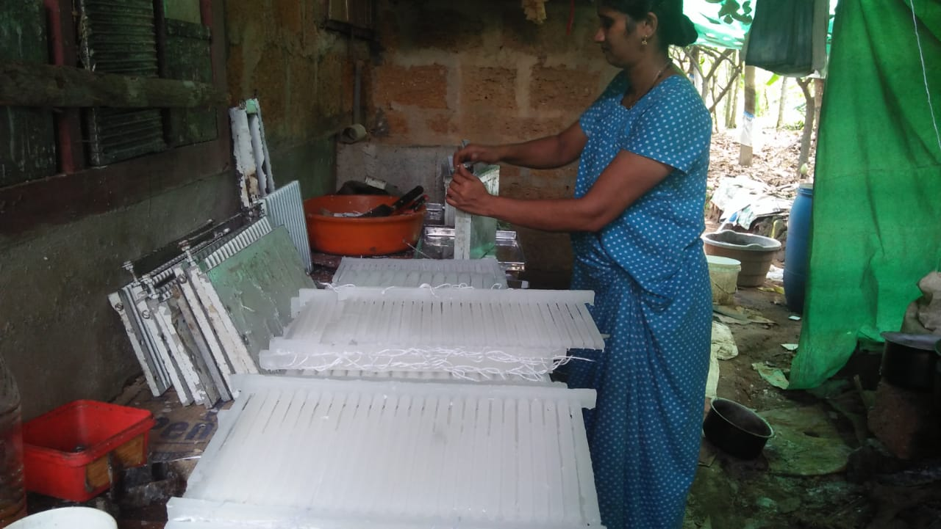

During 2017-18, five families utilized SAFP fund for cattle rearing, Twenty nine families were engaged in goat rearing, seven families engaged in fish business, sixteen families in poultry and sixty two families were engaged in tailoring. Most of them earn good income from tailoring and find their livelihood. Twenty eight families started small scale businesses like catering, confectionery making, curry powder making and packing etc. Eight families started readymade cloth sale. Eleven families started petty shop to find their livelihood

Development of basic amenities
FDP families attained notable development in basic amenities such as housing, sanitary, latrine, electricity and drinking water. 12, 50,000 were utilized for the development of basic amenities, during the reporting period. Two hundred and seventy families could improve their living conditions with our family development program during the last year. Some of them already became self sufficient and the rest are on the path of self sufficiency. They are able to meet the basic needs and to provide good education to their children.

II.KOLPING PROGRAM
Kolping is a program focusing on overall development of the members, especially for the spiritual and social development as the slogan of Kolping says: ‘Good parent, Good laborer, good citizen and Good believer.” At present 86 Kolping groups are functioning effectively and the total number comes up to 1180. Out of these, 15 groups are exclusively men’s groups, 8 mixed groups and 63 female groups. A total number of members in the male groups come to 255 and female 905. At present the membership is open to other religions also. Kolping conducts different types of training for personal and social development for its members.

- Livelihood program
During this period, we have provided assistance to 48 members to start small self employment schemes under IIGP and CIGP programs of Kolping India. The members

mobilized the rest of the amount from the SHG and other government approved financial institutions at a nominal interest rate. The self employment units started utilizing the assistance include Dairy farm, Goat rearing Fish wending, Soap making units etc. All these self employment schemes are well progressing and profitable. By this, the family income is increased and the quality of life has been changed to a great extend

B. Housing Support Program
Most of the members are poor and marginalized. Livable house is very essential for their life. The construction cost is very high and their dream of having a livable house is beyond their reach. We have already supported four of them for constructing houses within this period.
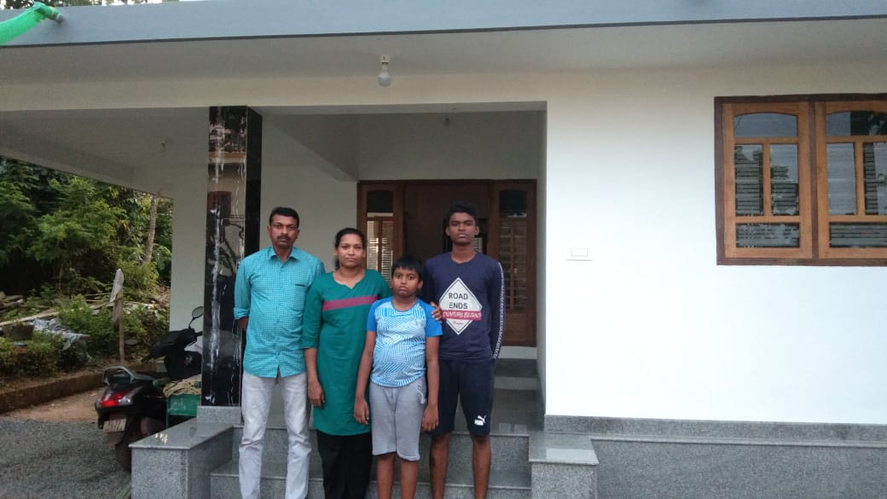

Capacity building Program
The knowledge and skills should be updated in order to improve the quality of managing any business. Account keeping and documentation are essential in the present scenario. We have provided different types of trainings for the Kolping members for updating their knowledge and development of their field of work. The training periods extend from one to three days. The main trainings conducted are given below.
- Microfinance & Book Keeping :
The book keeping and micro finance trainings are needed for the newly formed groups. Thus they were trained in the account keeping and managerial systems of group. The leaders gained confidence in financial management and accounting. The groups are keeping their books and records in well manner .The group systems and procedures are very transparent and systematic.
- Entrepreneurship Development Program (EDP) & Identifying Business Activities
The members of Kolping are mainly rural people and are not aware of the self employment schemes and financial supports. To give awareness to such groups, EDP training was conducted in these rural areas and selected members participated in the trainings. The topics covered different types of self employment schemes, quality of entrepreneurship, motivation, identifying the viable enterprises etc. At the end of the sessions, participants could identify their business based on their abilities and situations. Surprisingly we could see that many of them have already started their business in their own capacity.
- Women and child protection
The women and children are the most vulnerable group in the society. They are suffering from various atrocities in the society. The ignorance of law and other supportive aids are the main reason that they are taken for granted. In this pathetic condition KAIROS has decided to create awareness on these issues, through which this vulnerable section of the society will be uplifted. Thus we have conducted a special session for the protection of Women & Child. The Kolping members were capacitated to this subject and they were protecting themselves from harassment. The women are using their power in the society with the support of empowered women.
- RTI& Fundamental Rights
The trainings of RTI and Fundamental Rights were conducted at village and federation level .The SHG members participated in these programs. The expert team of KAIROS led the sessions and practical sessions were also conducted. The participants placed their complaints with the procedures of RTI. The training created awareness to women to change their attitude and capacitated to deliver all the issues properly and timely without the support of anyone
- Orientation on family values and effective Parenting
In the present world, people are busy with their own errands. The family relation and value of life, is decreasing day by day, and many family cases are reported to the Police station and divorce cases are increasing in our district. The people should know about the family values and inculcate mutual respect among the family members. KAIROS has given top priority to address the issues and conducted awareness class for parents in diferent levels. The district level health department team was associated with us and handled the sessions with their expert team. The people became more aware about parenting and family values and practicing their knowledge to the family. It was arranged at Mariyapuram and the Vicar Forane and former director Rev. Fr. Benny Manappat inaugurated.
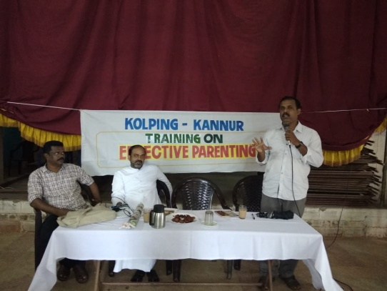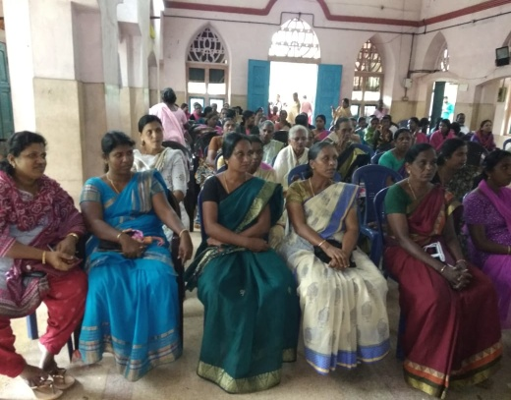

g. Waste management Trainings
Waste management or waste disposal is the necessity of the time and activities end action is required to manage waste from its source to its final disposal. In our country waste disposal is not in the right manner. Waste is often disposed in river, sea, road sides, and in other open areas. In the absence of proper waste management, the waste becomes a burden for the family .We selected one village in Pattuvam to develop zero waste management systems. KAIROS and Carmel waste management group Pilathara, provided the different type of trainings and practical session’s .The SHG group members started the Kitchen waste management systems in their home. The waste converted to fertilizers and utilized for the kitchen gardens. Waste management systems are being introduced to other areas.
h. Trainings against open defecation
Defecating in the open, is a very ancient practice .In our target area, some people practice this. The less land and absence of common toilet, forced the village people to use the open areas to meet their call of the nature. KAIROS provided awareness training for the consequences of open defecation and gave financial assistance for the construction of toilets attached to their houses.
I. Contaminated water.
As our operational area is lying very close to the Arabian Sea and estuaries drinking water is saline and thus contaminated. They are getting pure drinking water only during Monsoon. So, the health of the people was in danger, and they were suffering from different kinds of water borne diseases. KAIROS intervened in the situation and selected one village very close to water bodies and conducted different types of health awareness trainings on water borne diseases and conducted a rally with the support of Health department. Technical trainings were also provided for rain water harvesting, well recharging systems and other techniques to be practiced among the people to reduce water contamination and to store potable rain water and thereby to enjoy good health.
j. Networking & Linkages
Networking is for obtaining collective strength to be exercised by the groups, to achieve higher targets and objectives. The methods and procedures of networking among different people’s groups are imparted to the participants. They were also oriented on establishing linkages with financial institutions and organizations of similar natur

g. Waste management Trainings
Waste management or waste disposal is the necessity of the time and activities end action is required to manage waste from its source to its final disposal. In our country waste disposal is not in the right manner. Waste is often disposed in river, sea, road sides, and in other open areas. In the absence of proper waste management, the waste becomes a burden for the family .We selected one village in Pattuvam to develop zero waste management systems. KAIROS and Carmel waste management group Pilathara, provided the different type of trainings and practical session’s .The SHG group members started the Kitchen waste management systems in their home. The waste converted to fertilizers and utilized for the kitchen gardens. Waste management systems are being introduced to other areas.
h. Trainings against open defecation
Defecating in the open, is a very ancient practice .In our target area, some people practice this. The less land and absence of common toilet, forced the village people to use the open areas to meet their call of the nature. KAIROS provided awareness training for the consequences of open defecation and gave financial assistance for the construction of toilets attached to their houses.
I. Contaminated water.
As our operational area is lying very close to the Arabian Sea and estuaries drinking water is saline and thus contaminated. They are getting pure drinking water only during Monsoon. So, the health of the people was in danger, and they were suffering from different kinds of water borne diseases. KAIROS intervened in the situation and selected one village very close to water bodies and conducted different types of health awareness trainings on water borne diseases and conducted a rally with the support of Health department. Technical trainings were also provided for rain water harvesting, well recharging systems and other techniques to be practiced among the people to reduce water contamination and to store potable rain water and thereby to enjoy good health.
j. Networking & Linkages
Networking is for obtaining collective strength to be exercised by the groups, to achieve higher targets and objectives. The methods and procedures of networking among different people’s groups are imparted to the participants. They were also oriented on establishing linkages with financial institutions and organizations of similar nature

k. Kolping Day Ceberations.(photos )

We celebrate Kolping day in central level or federation level in the alternative years. Since last year we had central level celebration, so this year we had the celebration in six federation levels. In each federation we start the program with Holy mass, different cultural programs by the members and we concluded with the agape. Good number of members attended the program.

III.CARITAS INDIA
CARITAS is the International NGO supporting different NGOs functioning in various countries believing in Christianity. The NGOs working in different States of India are getting support for implementing different schemes especially for AIDS, Cancer, TB etc. In India this organization is known as Caritas India and its head quarters is at New Delhi. It was established on 1st October 1962.
- ASHAKIRANAM
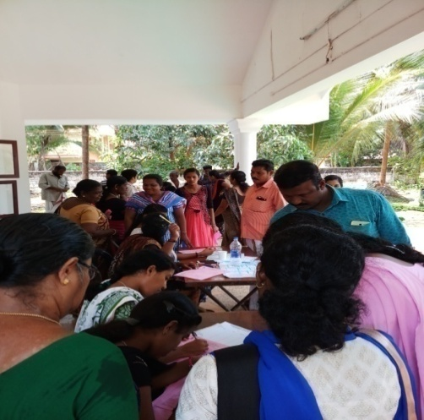
Ashakiram is a project initiated by CARITAS India to bring relief to the poor people of Kerala from the deadly disease Cancer. The work started at Ernakulam in 2014 is now spreading to all districts. According to the World Health Organization (WHO), there are 2.8 million Cancer patients now. It is projected to become 13.1 million by 2030. Therefore, the cancer safety program envisions the creation of a healthy society, fighting cancer, providing compassionate care to cancer survivors, providing better treatment facilities to their families and helping them succeed in government work. a cancer awareness class and early Cancer Detection Camp with support of Yenepoya Medical College under the leadership of Dr. Ibrahim Nagarur( Oncologist) was conducted as a part of the program.
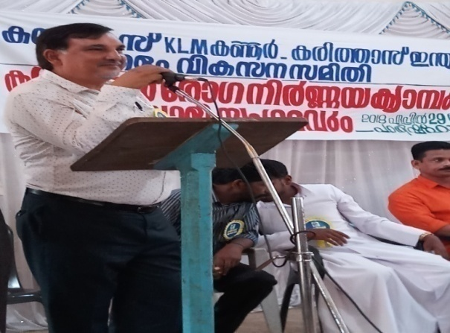
- ATHIJEEVAN
Athijeevan project aims at providing assistance to rehabilitate the victims of flash floods that happened during August 2018. We have provided resources for poultry farming for 100 families of Anayandagiri, Malayampaadi, Keezhpally, Kottukappara and Parakkappara, which consisting of 25 chicks and an Iron modern chicken cage. The project cost per unit comes to 15000/-. We have also provided assistance for 16 house repair and 8 toilet constructions, 7cow rearing and 7 goat rearing.
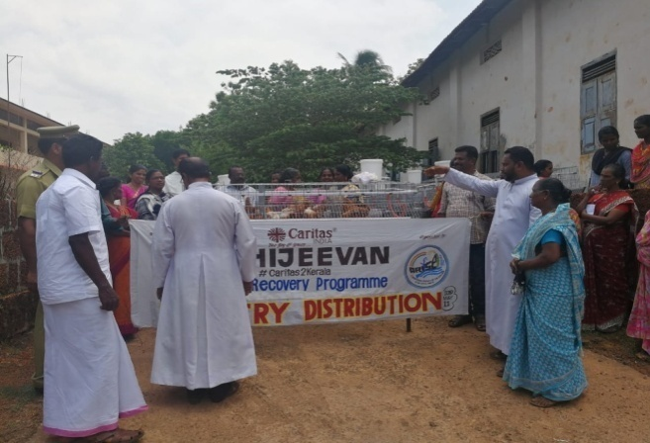

- Flood Relief Program
As we know very well, Kerala witnessed a flash flood during August and Middle Kerala suffered untold miseries and many lost everything including their lives. As a NGO, it is our commitment to wipe the tears of the affected and we intervened by collecting materials and supplied two vanloads of food materials and medicines to Ernakulam and Wayanad. A team of 20 volunteers went to Kottappuram of Ernakulam dist,for cleaning campaign. Certain places of Iritty Taluk of Kannur were also badly affected and two lost their lives. Agricultural land and infrastructure were also lost. We provided assistance for house construction and livelihood support.

NAVAJEEVAN PROJECT
Building Resilient Communities through DRR-Capacity Building Initiatives in the Flood and Landslide Affected Regions
Geographical Focus:
10 Gram Panchayat wards in KANNUR district

Overall Objective:

To capacitate and empower men, women, children, elderly, special groups and other categories of people in 10 geographically, socially, economically and environmentally vulnerable Panchayat wards with little or no capacity to withstand untoward events through resilience building and disaster awareness programs

Specific Objectives:
- To create a concrete group of Caritas Samaritans (Caritas India’s and KAIROS Kannur official volunteer army) in each of the 10 selected Panchayat wards
- To enrich the disaster knowledge of communities and create awareness about the need for disaster preparedness program.
- To build an army of first responders through the formation of Disaster Task Forces
- To prepare a Participatory Ward Level Disaster Preparedness and Response Plan
- To create platforms for interaction with local and state administration and to integrate the ward level plans into atleast local level Panchayat development plans

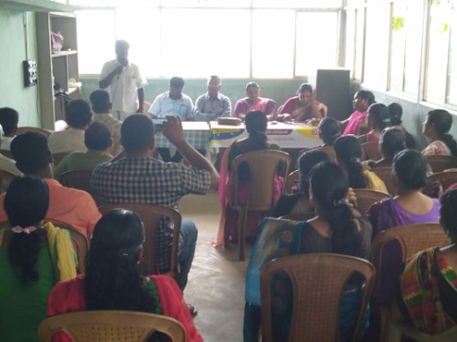
In the aftermath of the Kerala Floods of 2018, an emerging and pressing need for Disaster preparedness in Kerala was observed. The tragedy of 2018 was sudden, and people weren’t expecting or prepared for the impacts of the disaster. As part of emergency relief, response and recovery, several humanitarian organizations, NGOs, government and well-wishers had come forward to support the ailing population. Kerala received massive support for rebuilding, however, in this context, it is also important to create armies of self-sufficient, well-prepared communities who can fight and face future disasters. Until now, the affected populations were the receivers of aid, now is the right time to transform these communities into resilient communities who are aware and prepared to face and fight future disasters.
In order to take the concept forward, Caritas India, the second largest humanitarian network globally as well as the social wing of the
Catholic Church in India, along with KAIROS Kannur is aiming for an ambitious project where in 10 wards at risk of facing disasters are selected from Kannur District in collaboration with Panchayat Members.

IV. NATURAL RESOURCE MANAGEMENT
1. Environmental protection & Conservation

Natural Resource Management (NRM) is one of the major and important areas of intervention of KAIROS and has a very good track record in the implementation of sectoral programs. KAIROS is implementing five Watershed Programs under Western Ghat Development Programs (WGDP), such as Naduvil GP, Alakkode GP, Cherupuzha GP, East Eleri GP and West Eleri GP. The activities carried out during the reporting year are manifold and are classified under three heads:–

i. Activities for soil and water conservation, 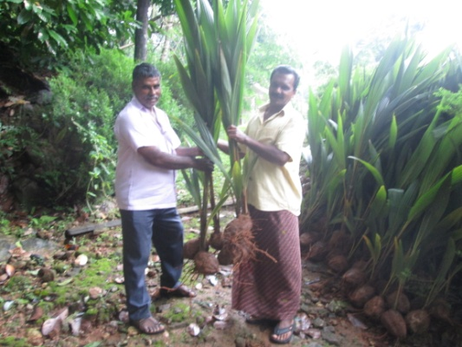
ii. Livelihood support
iii. Capacity building of the watershed community.

All these three categories of programs led to sustainable Natural Resource Management which helped the people to understand the need of conservation of natural resources. The conservation activities rescued the farm land from deterioration. Empowerment and sustainable livelihood of the landless and vulnerable sections like tribal and women are also important in the program.
In this financial year the achievements are: construction of contour bund 11500 M², retaining wall 650 RM, Agrostolegical measures 4500 RM, Loose board check dam 32, Weir 2, Live fencing 300 RM. are going on as per plans.

2.Jalam Jeevanam Programs

The scarcity of Drinking water is a crucial issue of coming generation. Water is the gift of God and it
may not be wasted. Water is most essential for the life of all the creature of world.
The NABARD started Jalam jeevanam program with support of NGOs.
KAIROS prepared a brief report about water related issues and remedial measures
were also given. We have associated with six panchayats in Kannur and Kasargode districts, such as
Pariyaram, Pattuvam, Chapparapadavu, Eramam Kuttur, Kayyur chemeni and East Eleri-
Total 100 wards were covered. We are conducting the PRA tools in 100
wards and collected the data and information from the grassroots level. The NABARD
Officials, Panchayat president and team along with the public allied with us.
Taliparamba MLA, Mr.James Mathew inaugurated our programs and by the end, we
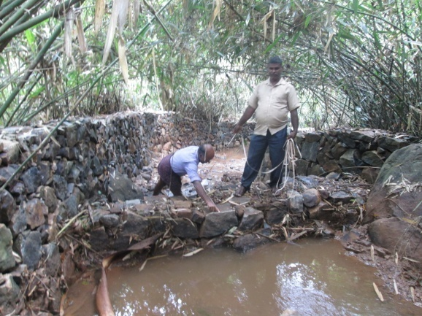
prepared the report and submitted to NABARD office

V. Jalanidhi Project
"Jalanidhi" aimed at sustainable and people managed water supply system in Rural Areas. KAIROS, as Supporting Organization, has implemented two JALANIDHI-projects in Kannur District – one in Kolayad Grama Panchayath (GP) and the other in Irikkur Grama Panchayat. The project also promotes total sanitation, Ground water recharging, and GP level strengthening, through Technical and general trainings to the project stakeholders. Jalanidhi is seen more a demand driven than need based.
We have completed 21 beneficiary groups in Kolayad gramapanchayat and a bulk water scheme in Irikkur gramapanchayat

VI. KSBCDC-. Income Generation Programs
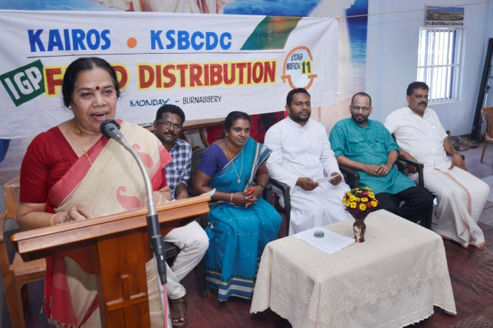
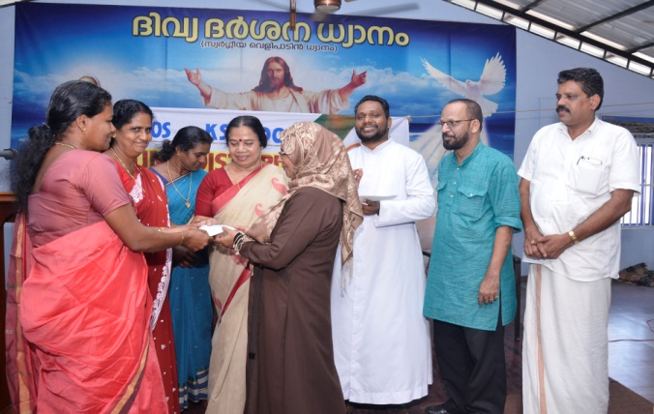
KAIROS particularly promotes Income Generation Programs (IGP) for economically weaker sections of the community, which are expected to be supplementary to their well being. Training, that would enable them to face the difficult situation in the ventures, are organized and conducted. Financial support was arranged with the support of financial institutions especially KSBCDC, through linkages and lobbying. Finance was also arranged with SHGs and their Federations, who channelized funds from the savings of its members. Every possible support and follow-up is extended to individual entrepreneur by the expertise of KAIROS staff. In the reporting year, around 225 individual prospective entrepreneurs, selected from 48 groups, started the IGP’s and are moving smoothly. Some of the schemes are internet café, goods auto, poultry farm, garments unit etc. An amount of Rs. 1,00,00,000/-(One Crore) was channelized from KSBCDC which was used to support the deserving candidates/families to start IGPs. The launching of the program was inaugurated by the Hon’ble MP Smt. P K Sreemathi Teacher, in a colorful function presided over by Rev. Fr Shaiju Peter, Director KAIROS. Mr. Sudhakaran Manager of KSBCDC, Kannur gave a class on IGP’s. Mrs. Sapna, Vice- President (Block Panchayath) of Kannur, felicitated the function.
b
VII.Women’s Day Programme
International Women’s day was observed on March 7 at Iritty Vyakulamatha church. The function was inaugurated by Smt. N.T Rosamma Irrity Block Panchayath president. Advocate Sheeja Sebastian, Ayyankunnu Grama Panchayath President gave a class on women empowerment.
VIII. KERALA LABOUR MOVEMENT
During the reporting year KLM Kannur, has actively involved in registering and renewing new members and existing members in different Kshemanidhies. In Tailoring, we have enrolled 85new members and renewed 60, likewise, in shops and commercial establishments we have enrolled 15 new members and renewed 405 members. So far 1 marriage assistance and 2 maternity benefit claims were given. Under suraksha scheme, 504 members have renewed in the reported year.

KLM Kannur celebrated May Day with vigor and enthusiasms at Bakkalam. A Holy mass was arranged and a rally was conducted. Most. Rev. Dr. Alex Vadakkumthala (Bishop of Kannur) inaugurated the meeting. Our Bishop was garlanded by KAIROS Director for becoming the CBCI Labour Commission Chairman. Different Trade Union leaders felicitated the function. Cultural programs by the migrant workers were also staged. 450 members including migrant workers participated in the program
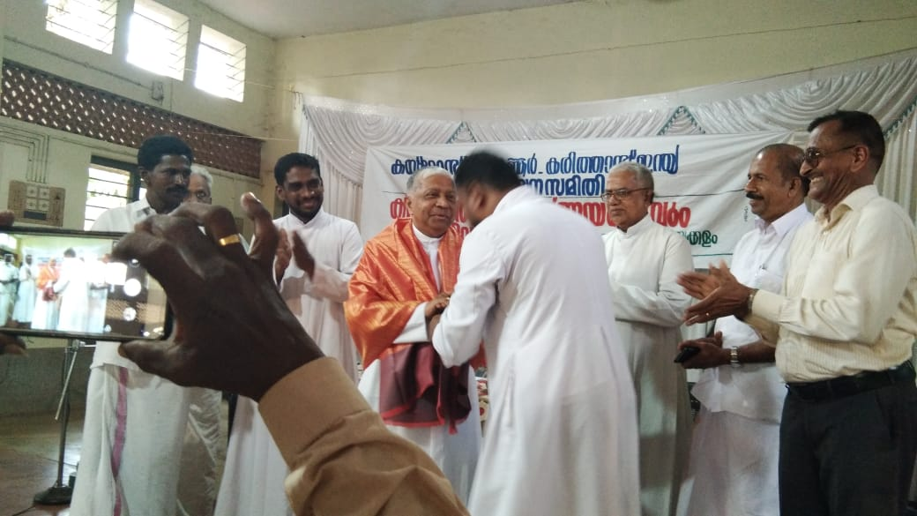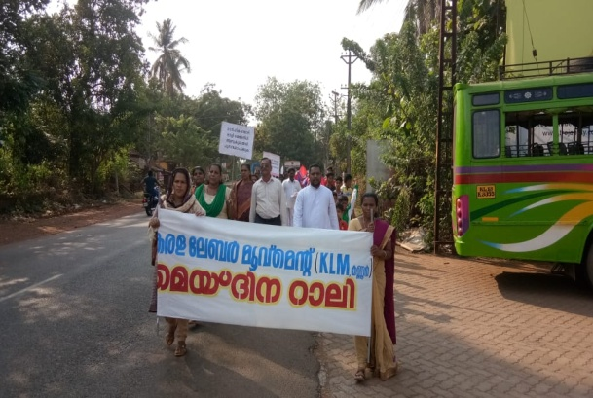

a.Lay leaders meeting
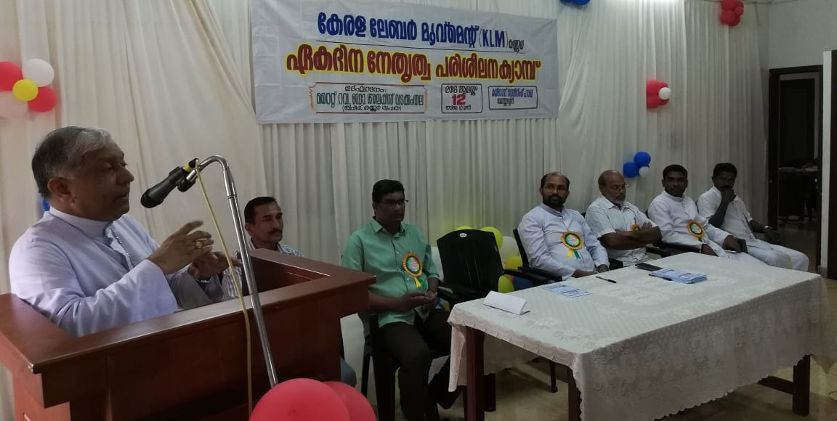
An action force of unorganized workers was formed to initiate relief measures to those who are suffering from different types of natural calamities- Bishop Dr.Alex Vadakkumthala, the Bishop of Kannur diocese and CBCI Labor commission chairman inaugurated the one day training camp for lay leaders conducted at KAIROS training hall at Kannur on 12 August. The camp was organized as directed by KLM state committee. Whenever a calamity occurs, the affected people are put into untold miseries and are looking forward for help. They need immediate help. This kind of action force will be of great help for them. Sri. Santhosh C C , Regional forum President presided over the event. Sri. K V Chandran, the KLM coordinator welcomed the gathering. Rev.Fr. Vimal Victor, Director of KLM felicitated the function. Smt. Mary Salma expressed vote of thanks. After the inaugural session the training session started. The first session was" Contemporary situations and reactions of KLM" handled by Sri. Joseph Jude, National President of WIF. After this a Holy Communion was held. After mid day meal the second session started and the topic" The activities of KLM" was handled by Rev.Fr. George Nirappukalayil, KCBC Labor commission Secretary and KLM State Director
Sri. Stephen Kottarathil, Malabar Region Secretary discussed about the planning and future activities Sri. Santhosh C.C delivered the vote of thanks to the State leaders. Seventy six lay leaders from 32 units attended the camp. The program came to an end by 4'o clock. The program was widely covered by the media.

b.Training for Priest and Religious Sisters
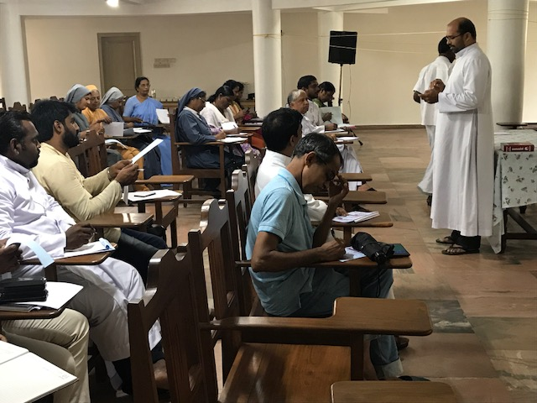
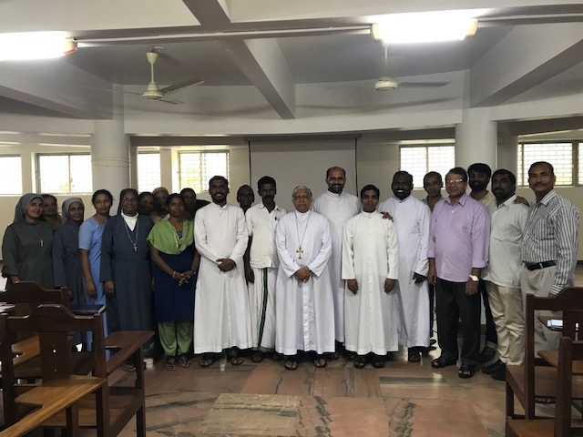
As per the directions of KLM state office,the regional forum of Kannur, arranged a half day training for regional level priests and sisters at the Bishop's house on 27th August .The program commenced at 10.30am and came to an end by 2 pm. Fr.Vimal Victor, KLM Kannur Director welcomed the gathering.Sri.Santhosh C.C,regional forum Present presided over. Kannur Bishop and CBCI Labour Commission Chairman Rt.Rev.Dr.Alex Vadakkumthala inaugurated the workshop. He made an allusion about the flash flood and landslides and the miseries of the affected people and about the intervention of KLM in such situations. The training session that followed was handled by Rev.Fr.George Nirappukalayil, State director of KLM and KCBC Labour Commission secretary. The origin and development of KLM, the social and economic status of the working class, their income, their demands and the three main aspects such as health, family and oldness was narrated. As the layman is working for the state, it is the duty of the state to provide welfare measures in return. For this KLM has a vital role. Many doubts and concerns were cleared. Sri. K.V.Chandran, KLM coordinator expressed vote of thanks.
c.Aavaz -Bio-metric cards for migrant workers at Payangadi of Kannur
With the support of Dist.Labour Office , KLM Kannur arranged Aavaz- Bio-metric card camp for the migrant workers of Payangadi area. After discussing with the Dist. Labour Officer, an awareness class was conducted for the workers, who can follow Malayalam. The class was handled by the KLM Coordinator. The workers showed their willingness to have the Bio- metric card. Thereafter the situation was discussed with the Asst. Labour Officer and four camps were arranged. The first camp was held at Payangadi Sacred Heart Church. Due to certain technical problems the next three camps were shifted to Madai Public Library Hall. Around Two hundred cards were issued through these four camps. The Asst. Labour Officer Sri.Priyesh and three other staff from the Department actively cooperated with this program. KAIROS Regional Coordinator Sri. V. James helped the KLM Coordinator in all these programs. These camps were conducted on 1st, 4th, 29th and 30th of june 2018.
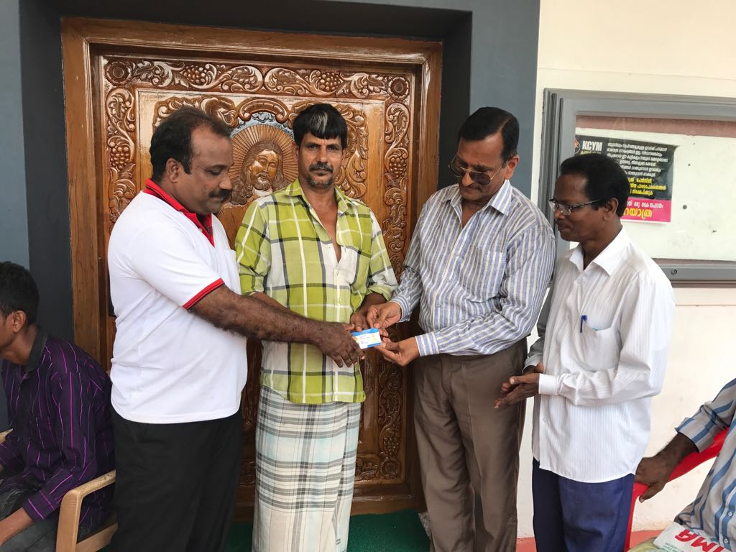

VIII. SOCIAL IMPACT STUDY (SIS)
Under the scheme, we have already prepared and submitted 8 projects to the District Collectors of Kannur and Kozhikode Districts. Out of these, in Kannur, we have received 6 projects, and they are as shown below

- Land Acquisition (LA)for Melechovva under pass
- LA for KIAL
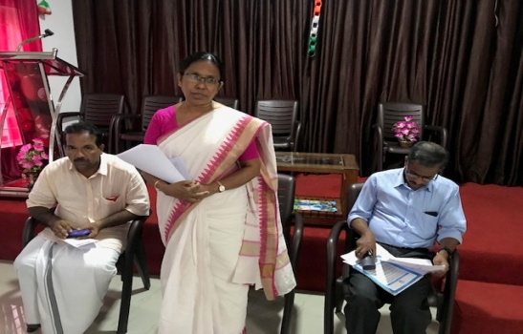
- LA for integrated development of Payam GP
- LA for Payyavoor GP drinking water
- LA for Tly-Valavuppara in Vilamana village
- LA for Tly-Valavupara in Eranjoli village

Hon. Health Minister Smt. Shylaja teacher evaluating the progress of SIA at Koothuparamba
Likewise, we have already prepared and submitted four projects under SIA to the District Collector Kozhikode and all four projects were sanctioned. The report of these four was submitted to the Collector Kozhikode. The projects are as shown below

- Land acquisition for Moorad ROB
- LA for Kalluthurkadavu shopping complex
- LA for Thondilakadavu bridge approach road
- LA for Chediyalakadavu bridge approach road

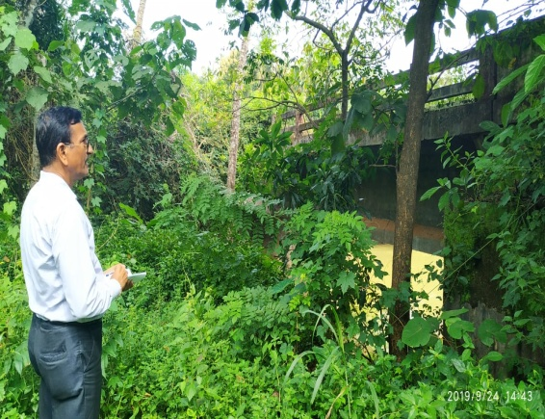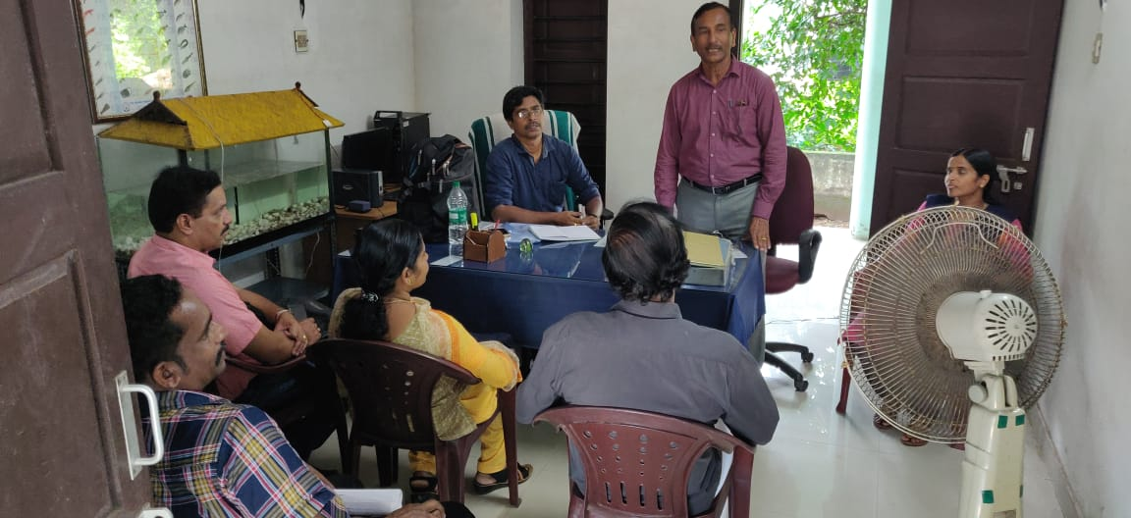

IX. E-Shakti
E-Shakti or Digitization of SHGs is an initiative of Micro Credit and Innovations Department of NABARD in line with our Hon. Prime Minister’s statement, 'we move with the dream of electronic digital India’. Digital India is Rs 1.13-lakh crore initiative of Government of India to integrate the government departments and the people of India and to ensure effective governance. It is to "transform India into digital empowered society and knowledge economy".
Under KAIROS, at present 325 SHGs are functioning actively. Out of this 200 SHGs comes under the E-Shakti program of NABARD and they are updating their monthly accounts through E-Shakti. Six coordinators are deployed for this program.

XI. ERIN(Europian Reintegration Network)
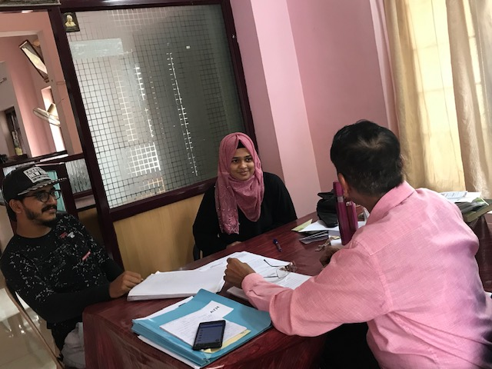
During this year we have under taken a case under ERIN project by Caritas India. This scheme is to give assistance to the deported unauthorized residents of UK, Jermany, USA etc. for starting an Income Generating Program based on the project submitted by the beneficiary. The assistance given under the scheme is three thousand Euro per person. After getting information from Caritas India, our Program Officer paid three visits to the house of the returnee to verify the project proposal of Mrs. Rasheedha Anjilath pollayil Kasargod, who was deported from UK. And she was given assistance for starting computer centre under this program. Besides this support, monitory assistance was given for the education support of her son Muhammed Hanan.

Conclusion
Capacity building of the people, empowers them, to take up the grievances and severe issues that negatively affects the development of the people and communities at the grass roots level. The capacity building programs and other awareness generation programs organized and conducted by KAIROS has achieved a certain range of development among the people. We are also committed to continue our capacity building programs in the coming years also.

People must have the opportunity to decide and determine their priorities. Many of the programs helped the people to do so. Most of the groups are taking off their destiny and are preparing themselves to go further. They also seek to gain control and access to resources. Economic empowerment is one of the means to empower the grass root level population. Enhancing women’s economic productivity at the grass root level, they need to be empowered. An important strategy for improving the welfare of hundreds of households is economical empowerment. Our effort is to make the groups self reliant in terms of resources and access to resourceful institutions who are dedicated and committed to the cause of upliftment of the poor.
We are thankfully remembering the agencies and institutions which were instrumental for the achievements of KAIROS during the reporting period. If it is not for their support and guidance, these achievements would not have been happened. We expect the similar support, cooperation and guidance from those partners for the coming years also.
A few words of gratitude for the whole team of KAIROS for having been the instruments for the transition taking place among the poor and marginalized, the new horizon of achievements in the socio economic development, and for the creation of the future generation who are ready to work for their own development.

Rev. Fr. Shaiju Peeter
Director - KAIROS

