KAIROS

Annual Report
2017 -2018

Introduction:
Kannur Association for Integrated Rural Organization and Support (KAIROS) was formed and registered under Charitable Societies Registration Act in 1999. This is the official organ of the Mission Diocese of Kannur (The Diocese is formed in 1998 bifurcating the Diocese of Calicut consisting of the most backward northern Districts of the state – Kannur & Kasaragod) for the Socio-Economic Development of the poor and marginalized. KAIROS is a non-profit non-government organization functioning for the development of rural women in 65 villages of the operational Districts.

KAIROS is equipped with skillful staff members with adequate qualification and specific in house training and are committed to the cause of the poor and marginalized, especially women. Among the staff is one project officer, One General coordinator Three Regional Coordinators and 65 Village Coordinators. Besides these there is a squad of administrative staff to carry out the daily business of the office.

KAIROS has entrusted with the already existing People’s Organizations – the Women’s Organizations and Credit Unions – formed and facilitated by the undivided Diocese of Calicut. Later KAIROS transformed these People’s Organizations into SHGs, and clustering the SHGs, Village Development Committees (VDCs) is formed. The women SHGs were supplemented with the available resources with KAIROS. Now the Organization is running short of resources to continue its mission and its supporting role with the emaciating resources. It is difficult to continue supporting the ever increasing needs of its target community and hence decided to shift its approach to the grass-roots level groups in making them self sufficient. In order to effectively involve in the development sector KAIROS decided to bridge the resource gap for its various development interventions. KAIROS has several consultations and has conducted participatory process before formulating this proposal. As per the present situation, the operational area of KAIROS has divided into six regions in which there are 320 SHGs (Both men and women) 86 Kolping Units and 62 childrens’s groups (Balavedis). All these CBOs cover a total 28536 beneficiary families.
1.FAMILY DEVELOPMENT PROGRAM

Save A Family plan supported Family Development Program is an outstanding program in the developmental field of KAIROS. Under KAIROS, about 875 families were already availed their support from SAFP. At present we have 301 families under the Save A Family Plan Program. During 2017-2018, 58 families were newly selected for the program. 65 families completed their period under this plan and were cancelled from the program during the reporting period, and they became selfsufficient. Rupees 57, 62,542/- was disbursed among 349 beneficiary families for various purposes, during the last financial year. Out of these 349 families, 79 families have closed their bank account and received the closing balance, as their SAFP support was stopped.
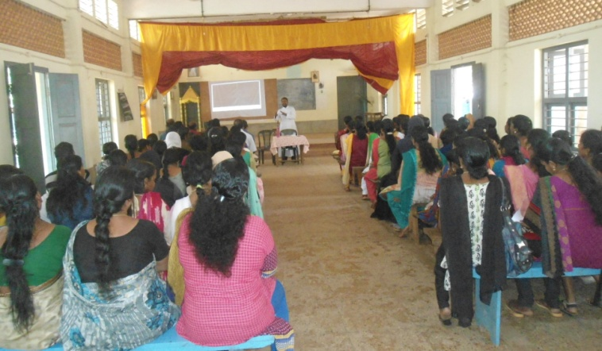
Capacity building programs
Family Development Program aims overall development of poor families, by the attainment of self sufficiency financial as well as social sphere. Capacity building trainings and entrepreneurial development programs are part of the family development program.
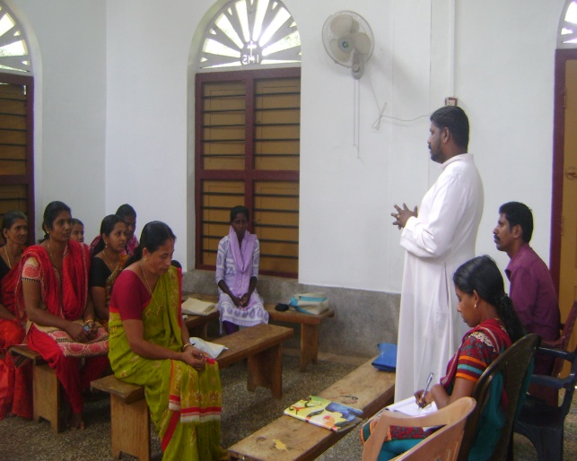
During the reporting period, we have conducted six awareness classes in regional level and 82 classes in centre (unit) level for the family development program beneficiaries. The classes covered the subjects like Income generation through self employment, end user awareness, water conservation, energy saving methods and so on.
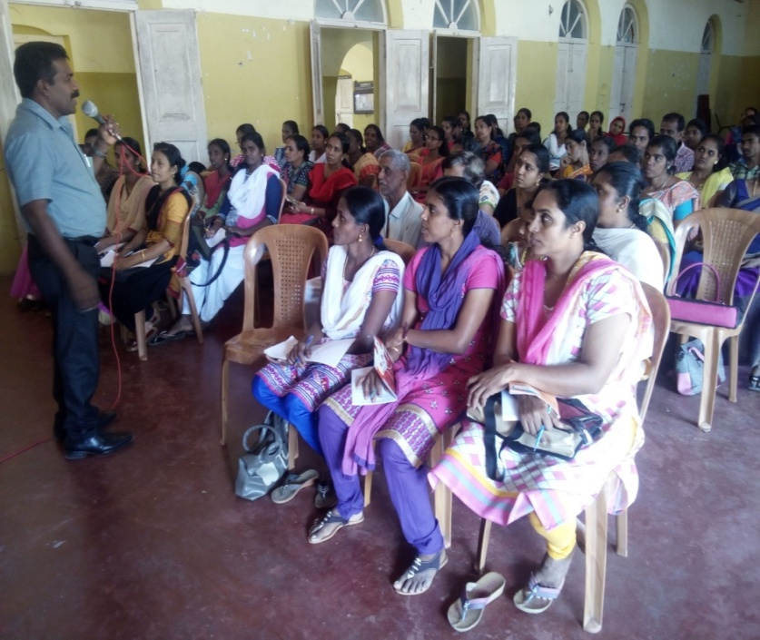
Income generation programs are the main part of family development program. FDP families get the financial support for a period of maximum six years and so they prepare plan for six years. Each year has special plan either for a livelihood initiative or for the attainment of basic amenities of life.
We have conducted two EDP trainings to give guide line and motivation to start income generation programs.
The programs aimed:
- To orient and motivate the beneficiaries to start IGP.
- Conceptual clarification of term Entrepreneurship
- To provide necessary knowledge and techniques on entrepreneurship and marketing management
- To build self-confidence and self-reliance
One day EDP training was held at Holy Trinity Cathedral Church Hall Burnassery, Kannur. Mr. M.K. Prakash, the resource person and trainer of Kerala Civil Service Academy, Kannur led the class. The class emphasized the importance of self-sufficiency, scientific methods of doing small business, attainment of the higher levels of goals, marketing techniques etc. Sixty Nine members were participated in the program.
Second EDP training was held at KAIROS Training Hall. KAIROS Director Rev. Fr. Shaiju Peter gave the class. Thirty six members were participated in the training. Practical sessions also conducted as part of the trainings. They earned skills in soap and soap powder making, detergent and cleaning lotion making, rosary and cloth mat making and so on.
The participants were motivated and gained more knowledge and skills of entrepreneurship.

Livelihood Initiatives
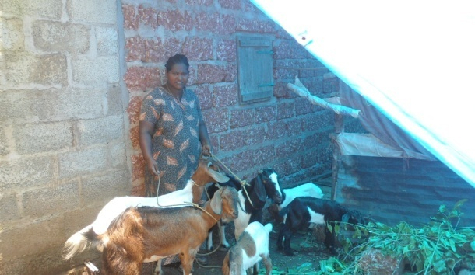
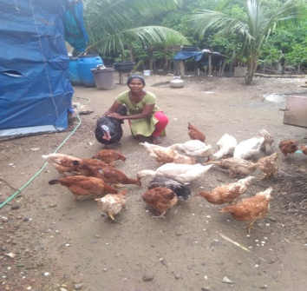
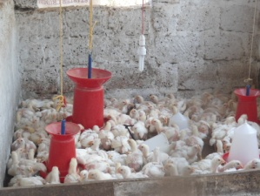
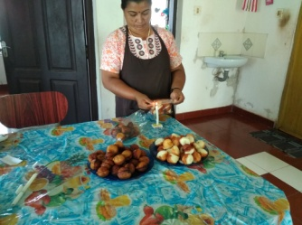
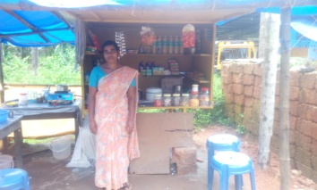
One hundred and seventy two FDP families have utilized their SAFP fund to start or expand various income generation programs, during the last year. They started the projects with small investment and gradually expanded it so as to generate a reasonable income.

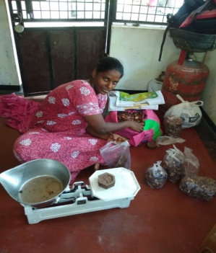
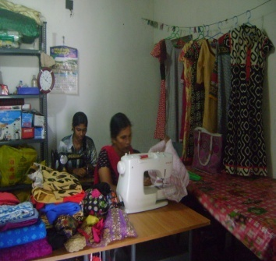
During 2017-18, five families utilized SAFP fund for starting or expanding cattle rearing. Twenty nine families engaged in goat rearing. Seven families engaged in fish vending and sixteen families in poultry. Sixty two families were engaged in tailoring. Most of them are earning good income from tailoring and finds their livelihood. Twenty eight families started small scale businesses like catering, confectionery making, curry powder making and packing etc. Eight families started readymade cloth sale. Eleven families started petty shop to find their livelihood
Development of basic amenities
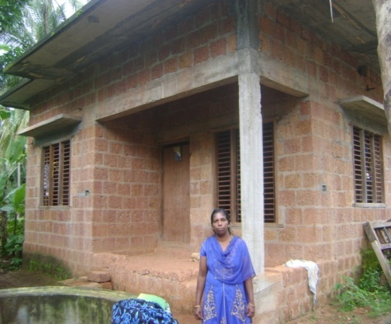
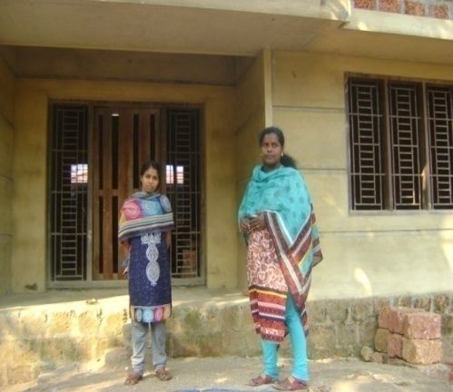
FDP families attained notable development in basic amenities such as housing, sanitary latrine, electricity, drinking water and so on. Twelve lakh fifty thousand was utilized for the development of basic amenities, during the reporting period.
Two hundred and seventy families could improve their living conditions with our family development program during the last year. Some of them became self sufficient and the rest are on the path of self sufficiency. They are able to meet the basic needs and to provide good education to their children.

.2.KOLPING PROGRAME
Kolping is focusing the overall development of the members especially for the spiritual and social development based on the slogan of Kolping such as Good parent, Good labour, Good citizen and Good Beliver. At present 86 Kolping group and total number comes to 1180. Out of this, 15 groups are exclusively men group, and 8 mixed groups, female group 63. Total male in 255 and female 905. The membership provides in other religious also and conducted different type of training to members for their personal development

- Lively hood program
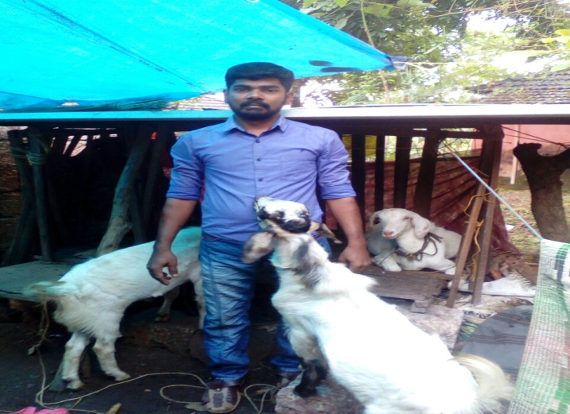
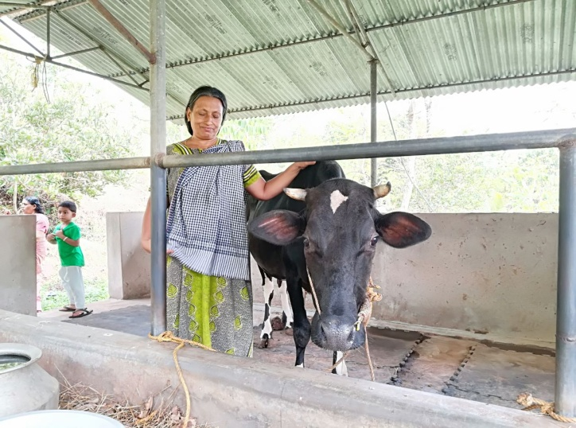
During this period, we have provided the assistance to 48 members to start a small self employment schemes under IIGP and CIGP programs of Kolping India. The members mobilized the rest of the amount from the SHG and other government approved financial institutions in a nominal interest rate .The different type of self employments started are, Dairy farm, Goat rearing ,Fish vending ,Soap making unit etc. All the self employment schemes are going well and earning additional income .Increased family income enhanced the quality of life
B. Housing Support Program
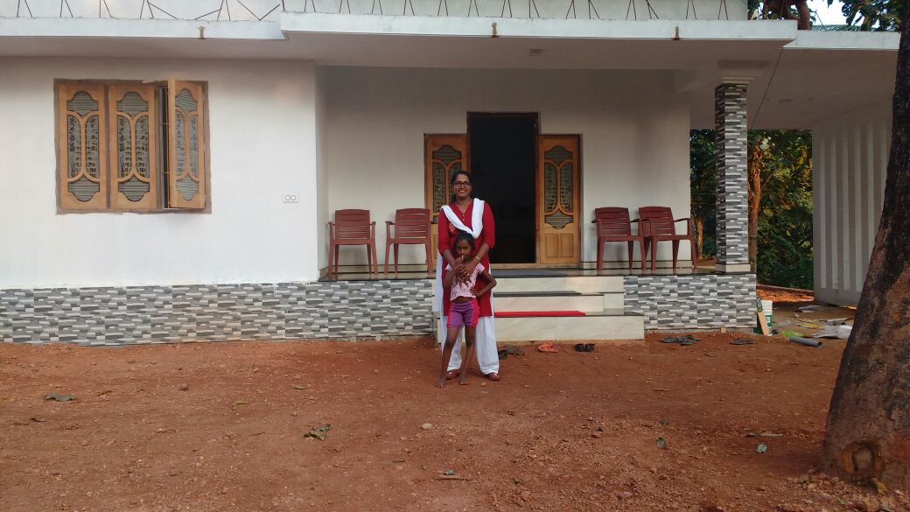
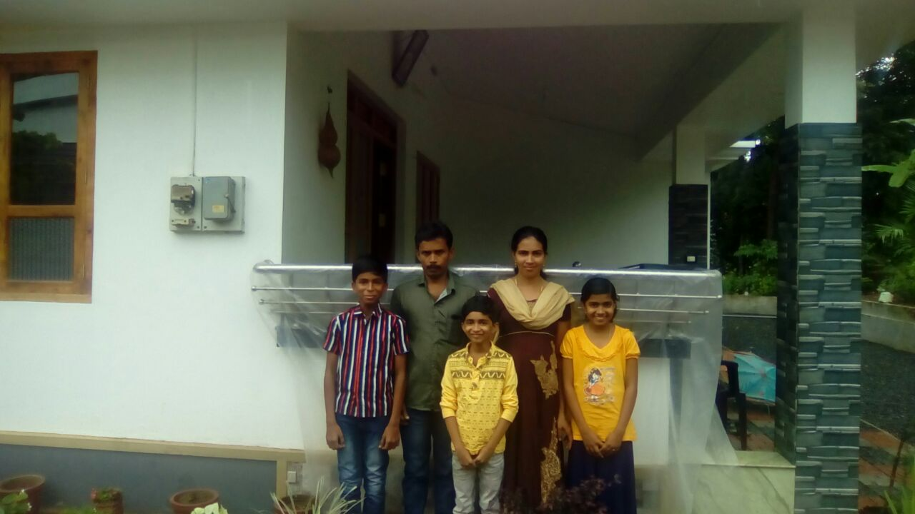
Most of the members are poor and marginalized .The livable house is very essential for their life. The construction cost is very high and their dreams can’t be fulfilled without the support from others .We have already supported four houses during this period.

Capacity building Program
Knowledge and skill updating improve the quality of management, updating the accounts and records, is essential for the present scenario .We have provided different type of trainings for the Kolping members for their development and institution. The training durations are one to Three days .The main trainings are given below.
- Microfinance & Book Keeping :
Book keeping and micro finance trainings are essentially needed for the new leaders and new groups. They were trained in the account keeping and managerial systems of the group ventures. The leaders were given confidence in finance management and accounting. The groups are keeping their books and records in well manner .The group systems and procedures are very transparent and systematic.
b.Entrepreneurship Development Program (EDP) & Identifying Business Activities
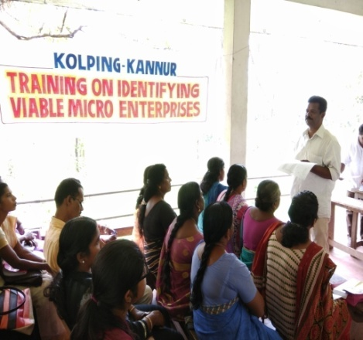
The members of Kolping are marginalized and rural people are not aware about the self employment schemes and financial support. To overcome the situation, EDP training were conducted in rural areas and selected members participated in the training. .The topics covered were different type self employment schemes, Quality of entrepreneur, motivation, Identifying the viable enterprises etc .At the end of the training, participants identified their business based on their abilities. The level of confidence improved and many of members started small enterprises.
c.Women and child protection
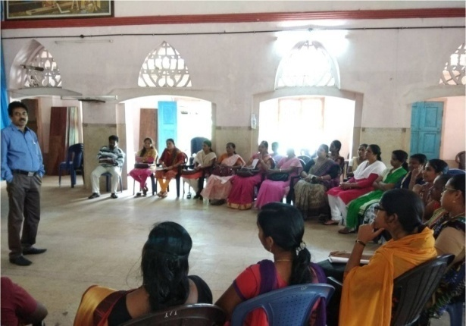
The women and children’s are most vulnerable group in the society. They are suffering from various issues of the society. The ignorance of law of women and child rights and other supportive aids are not getting familiarized in our target people. They were isolated from the society. KAIROS has decided to create awareness on the issues which lead conducting a special program on Women & Child Protection. The kolping members were capacitated in this subject and they were protecting themselves from harassment. The women can use their power in the society with the support of women’s rules.
d.RTI & Fundamental Rights
The trainings in RTI and Fundamental Rights were conducting in village and federation level .The SHG members participated in these programs. The expert team from KAIROS led the sessions and practical sessions were also conducted .The participants prepared their complaints with the procedures of RTI. The training created the women members to change their attitude and capacitated to deliver all the issues properly and timely without the support of anybody.
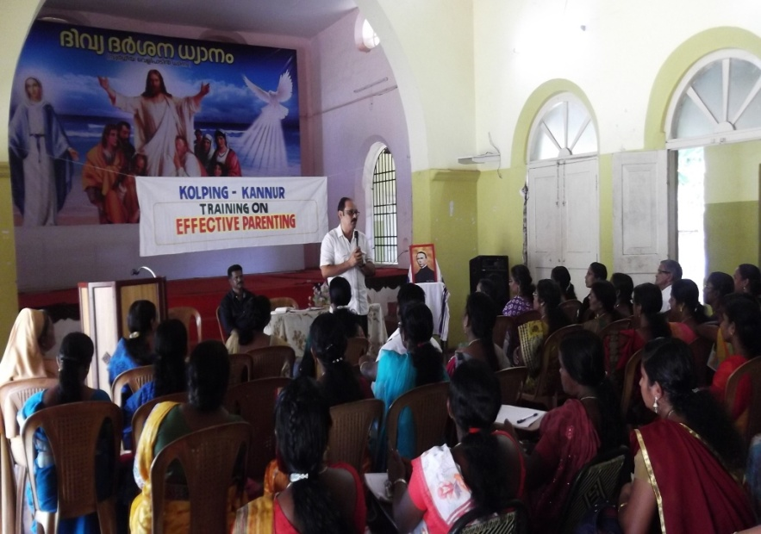
e.Orientation on family values and effective Parenting
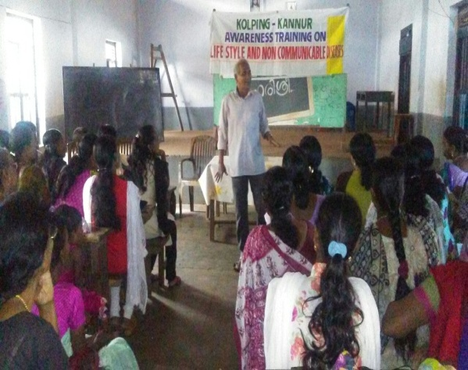
At present, people are more busy in their own duties and other responsibilities. The family relation and family values decreases day by day and many family cases reported to the station and the number of divorce cases increases in our district. The people should know about the family values and mutual respect among the family members. KAIROS gives top priority to address the issues and conducting the awareness classes for parents in deferent levels. The district level health department team was associated with us and handled the sessions with their expert team. People became more aware about the parenting and family values and practising their knowledge to the family.
f.Organic Agriculture Practices
We are selecting one village for the promotion of organic agriculture practises and conducting the different type trainings and exposure visit to organic agriculture fields .The Organic agricultural practitioner Mr.KBR .Kannan and Rtd. Agriculture officers of Agricultural department associated with us and led the sessions .The SHG members actively involved in the trainings and organic agriculture practice in their own field. The trainers equipped the participants the knowledge of production of different types of organic fertilizers.
g. Waste management Trainings
Waste management or waste disposal is the major issue which the modern society is facing, and action required to manage waste from its origin. In our areas waste is not disposed in the right manner. Waste is dumped in river, sea, and other waste land . In the absence of proper waste management policies, the waste is the burden for the family .We is selecting one village in Pattuvam to develop the zero waste management systems. KAIROS and Carmel waste management group Pilathara provided the different type of trainings and practical session’s .The SHG group members started the Kitchen waste management systems from their homes. The waste was converted in to fertilizers and started the kitchen gardens. Waste management system is to be introduced to other areas also.
h. Open defecation Trainings
Open defecation is very ancient practice .In our target area some people practise the systems. The main reason is that, the old type houses are not having toilet facilities and they are forced to depend the open grounds. KAIROS provided awareness training for the consequences of open defecation and constructed small sanitation facilities to the concerned houses.
i. Contaminated water.
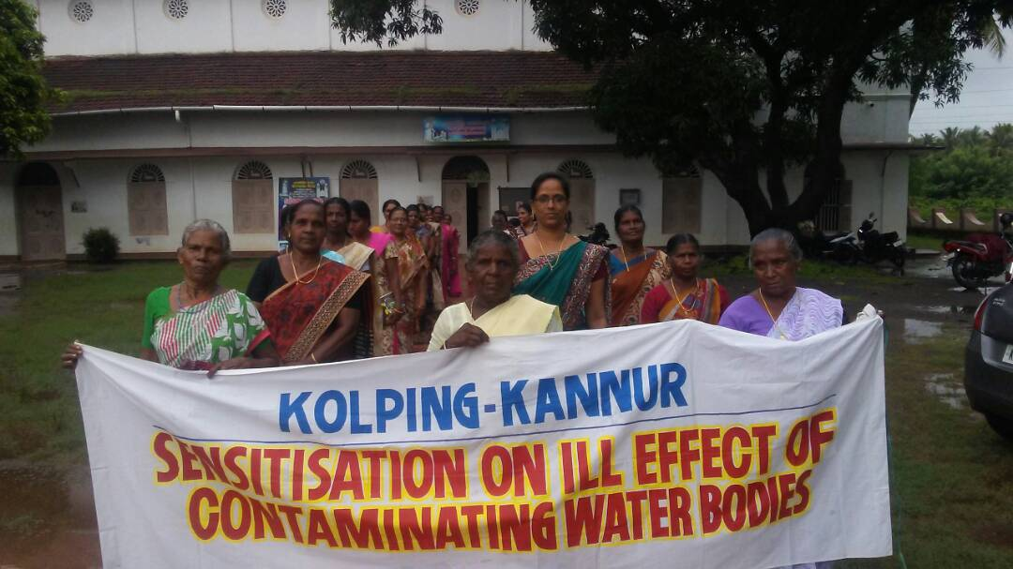
The back water areas are contaminated and affected the drinking water, and affects Health and people are proned to diseases. The Awareness trainings and other new methods of pure water system is essential for these areas .We selected one village in back water areas and conducted different types of health awareness training and rally’s based on water related with the support of Health department and technical trainings were also provided to rainwater harvesting. The Rain water harvesting tank, well recharging systems and other techniques are to be practiced to the people and thereby reduced water contamination.
j Networking & Linkages
Net working is for obtaining collective strength to be exercised by the groups to achieve higher targets and objectives. The methods and procedures of networking among different people’s groups are imparted to the participants. They were also oriented on establishing linkages with financial institutions and organizations of similar nature

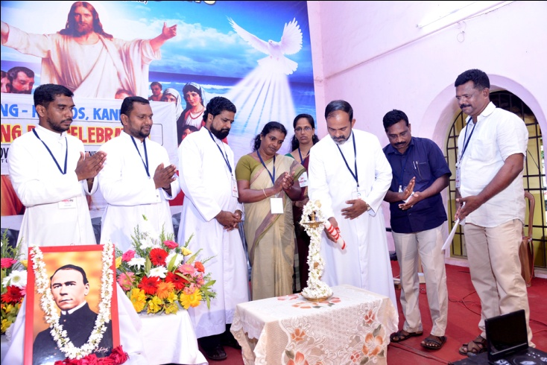
KOLPING DAY CELEBRATION
The kolping day was celebrated in central level .The Kolping members gathered together in central level and conducted different programs. Public function ,IGP exhibition cum sale, Cultural programs etc .The public function was inaugurated by Mrs.Sapna,Kannur block panchayat Vice.President .Fr,Beeny Manapat,Fr.Shaiju Peter,Fr.Vimal victor etc. participated in the programs
3. KERALA LABOUR MOVEMENT
During the reporting year KLM Kannur actively involved in registering new members and renewing existing members of different Kshemanidhies. In Tailoring we have enrolled 85new members and renewed 60. Likewise, in shops and other commercial establishments 739 we have enrolled sofar. 15 new members were enrolled and renewed 405 members. So far 2 marriage assistance claims were given. under suraksha 498 members renewed in the reported year.
KLM observed May day atIritty. May day rally, Public meeting, etc were arranged. Rt.Rev.Dr.Alex Vadakumthala ,Bishop of Kannur Diocese and and CBCI labour commission chairman inaugurated

4. NATURAL RESOURCE MANAGEMENT
1. Environmental protection & Conservation
Natural Resource Management (NRM) is one of the major and important areas of intervention of KAIROS and has a very good track record in the implementation of
sectoral programmes. As of now, KAIROS is implementing five Watershed Development Program under Western Ghat Development Programmes (WGDP): Naduvil GP, Alakkode GP, Cherupuzha GP, East Eleri GP and West Eleri GP. The activities carried out during the reporting year are manifold and be classified under three heads :–

i. activities for soil and water conservation,
ii. Livelihood support
iii. Capacity building of the watershed community.

All these three categories of programs led to sustainable Natural Resource Management which helped the people to understand the need of conservation of natural resources. The conservation activities rescued the farm land from deterioration. Empowerment and sustainable livelihood of the landless and vulnerable sections like tribal and women are also important in the program.
In this financial year the achievements are : construction of contour bund 11500 M², retaining wall 650 RM, Agrostoligical measures 4500 RM, Loose board check dam 32, Weir 2, Live fencing 300 RM. are going on as per plans.

3.Jalam Jeevanam Programs
The scarcity of Drinking water is a crucial issue of coming generation. Water is the gift
of God and it may not be wasted. The water is most essential for the life of all the
creature of world. TheNABARD started a Jalam jeevanam programs with support of
NGO.KAIROS prepared abrief report about water related issues and remedial measures
were also given. We are in six panchayat inKannur and Kasargode DT such as
Pariyaram,Pattuvam,Chapparapadavu,Eramam Kuttur,Kayyur chemeni and East Eleri-
Total 100 wards were covered .We are conducting the PRA tools in 100
Wards and collected the data and information from the grassroots level. The NABARD
Officials,Panchayat president and team, public associated with us .
Taliparamba MLA. Mr.James Mathew inaugurated our programs and by the end we
PreparedthereportandsubmittedtoNABARD office.

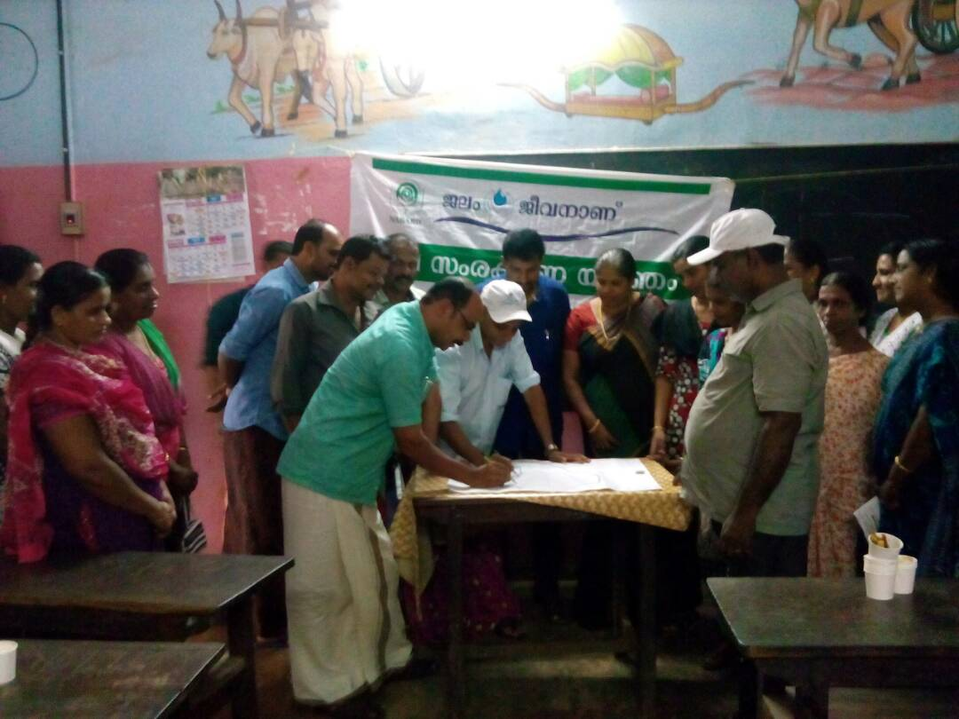
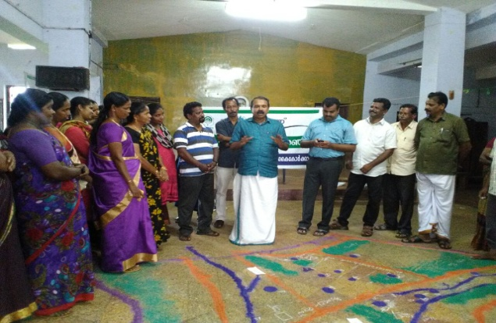

4. Environment day
June 5th, the Environment Day was celebrated at Pariyaram K.K.N Pariyaram memorial Higher secondary school. Our Director Rev.Fr. Shaiju Peter gave the message in the School assembly.. After that, another program including quiz was conducted in the hall. The public function inaugurated by Mr,Rajesh President of Pariyaram GP. Prizes were distributed to the winners of different programs.

5. Income Generation Programs -KSBCDC
KAIROS particularly promotes Income Generation Programs (IGP) for economically weaker sections of the community which are expected to be supplementary to their well being. Training that would enable them to face the difficult situation in the ventures are organized and conducted. Financial support was arranged with the financial institutions especially with KSBCDC through linkages and lobbying. Finance was also arranged with SHGs and their Federations, who channelize funds from the savings of its members. Every possible support and follow-up is extended to individual entrepreneur by the expertise of KAIROS staff. In the reporting year, around 225 individual prospective entrepreneurs selected from 48 groups started and helped to be sustainable. Some of the schemes are internet café, goods auto, poultry farm, garments unit etc….. An amount of Rs. 50,00,000/- was channelized from KSBCDC which was used to support the deserving candidates/families to start IGPs. The launching of the program was inaugurated by the Hon’ble Minister for Ports Shri. Kadannappally Ramachandran in a colourful function presided over by VG Msgr. Devasi Erathara.

6.Asakiranam programe
Cancer protection campaign initiated by KAIROS with the support of Caritas india.The reporting period different programs conducted in central level and village level.
a.Volunteer Sangamam and Hair donation camp
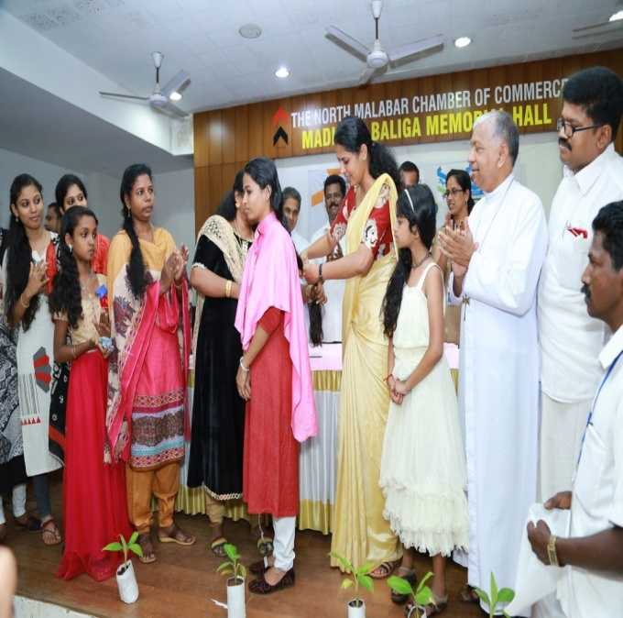
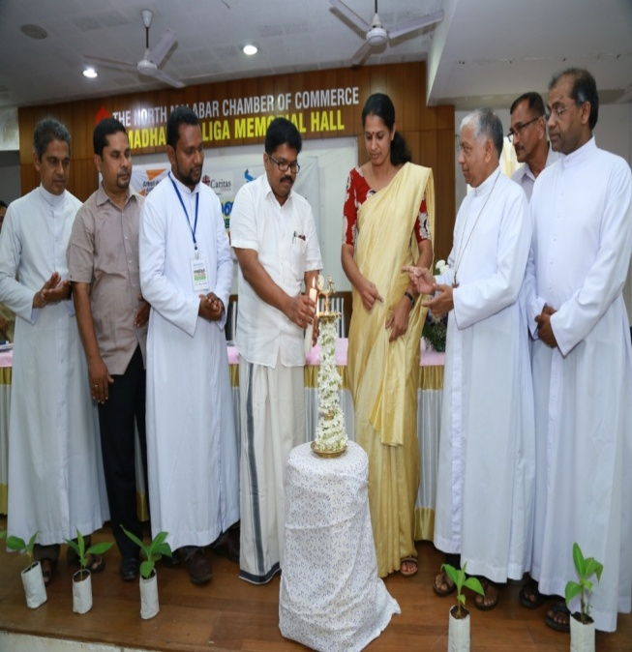
The Asakiranam voluters gatherred together at the Chamber of Commerce hall Kannur at the district level and conducted the public function. The public function was inagurated by Mr.K.K.Ragesh M.P and Hair donation camp was inagurated by .Mrs.P.P.Divya Vice president of Dist.Panchayat Kannur .Vicar Genreal Msgr.Fr.Clarance Paliath,Caritas India Director.Fr.Paul Mungely etc. partricipated in the program .32 volunteers contributed their hair for cancer patients for tha production of vig.The promotor sisters and volunteers also participated in the program.
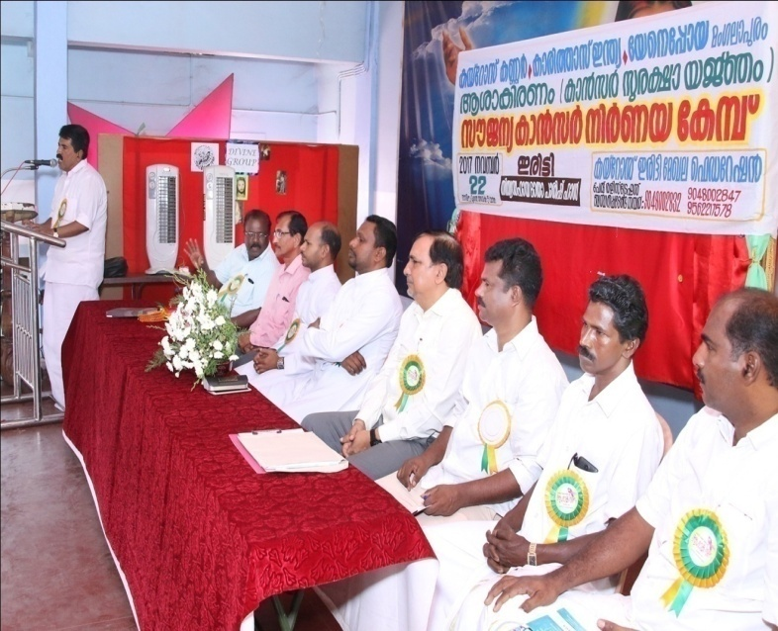
b.Cancer detection camp.
In the reporting period, KAIROS conducting the 3 cancer detection camps via Iritty,Bakkalam,and Kunhimangalam. KAIROS regional federation collabereated in Irity and Taliparamaba and at Kunhimangalam the alumni of Higher secordory school ( (S.S.LC batch of 1988)..Two camps lead by Dr Ibrahim Nagaroor,Oncologist , and team of Yenopoya Medical College,Manglore.The team examined breast cancer,Oral cancer,cervic cancer and general check up.The program at Kunhimangalam was inagurtated by Mr.TV.Rajesh M.L.A.Total 544 persons were examined. Cancer awareness class was also conducted.The results of this check up was given to the individuals and folloeup was given at concessional rates.

c.Painting competition
For the creation of awreness for the children, we conducted the painting competion for school children .The program was Inagurated by Rev,Fr.Jacob Jose.Mr Petre kolakat managed the competion .54 students of different schools participated in the program.
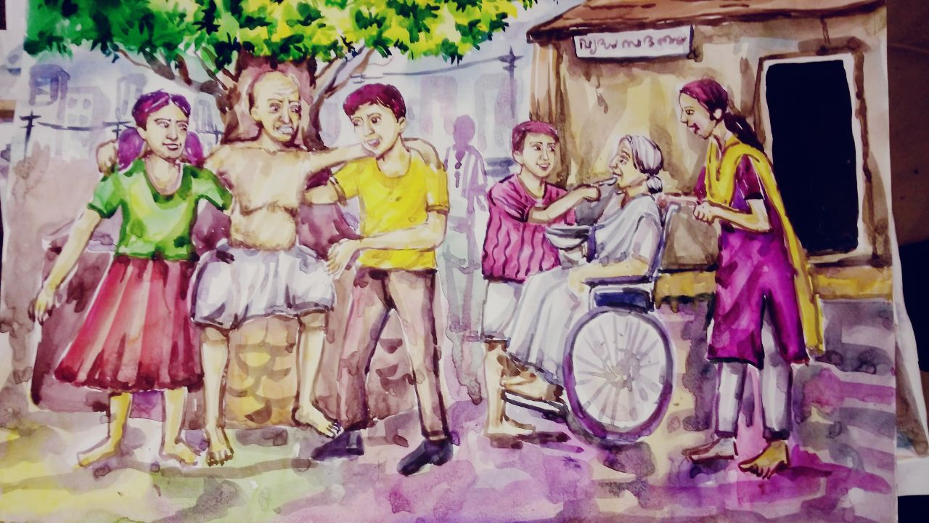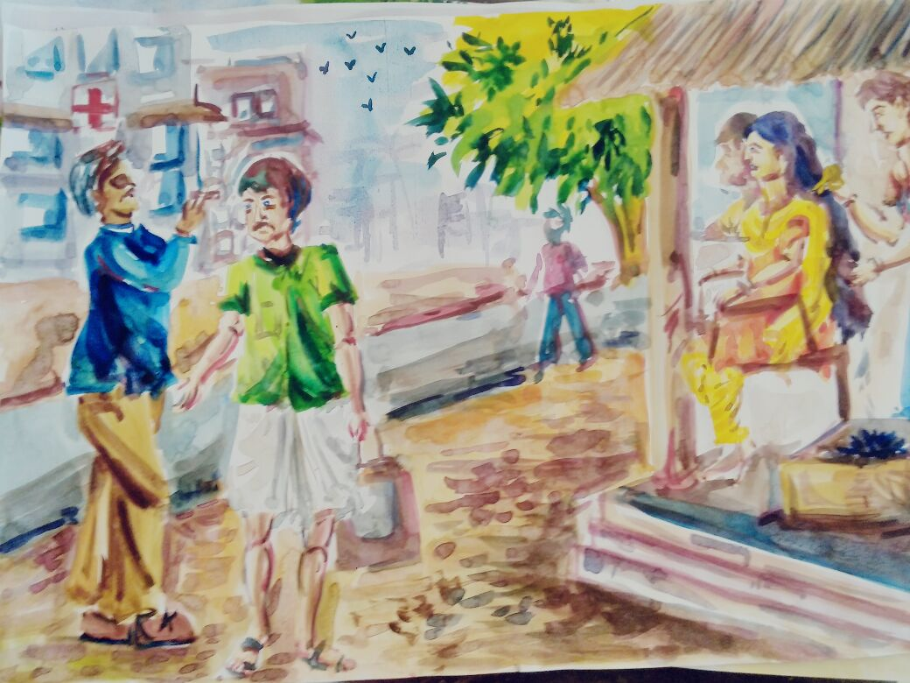
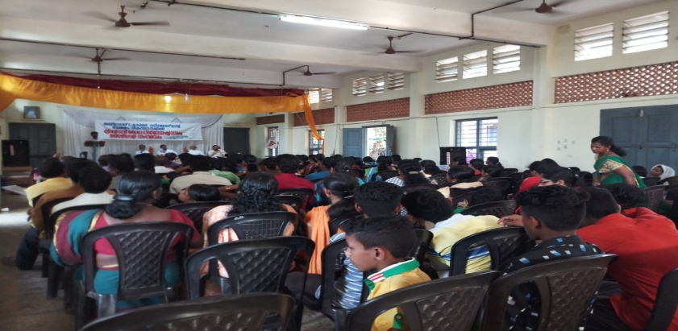
D.Cancer awareness class
Conducted 23 cancer awreness class in village level.The Govt health depatment ,Wellness group Kannur and KAIROS team handled the class in deferent areas.Total 198 membes participated in the programs.The people became more aware about their health and to control their food fast food habits.
D.Child protection Traininig
We have conducted the child protection training with support of child line kannur.The programs conducted in St.Pauls school Trichambaram.Mr.Mathew Thalliyil,Chairman of Child Welfare Committee Kannur inagurated and Mrs.Remani Ramand –Councillor Taliparamba Municipality and other dignities participated.The counsiling class was handled by Dysp and Circle inspoector Of Police.
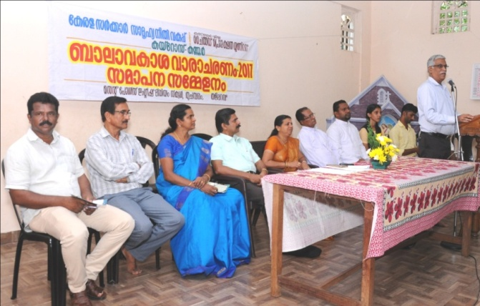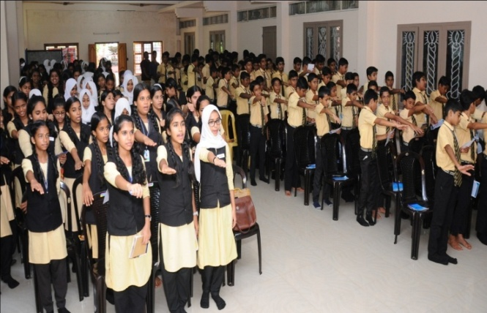
Jalanidhi Programes
"Jalanidhi" aimed at sustainable and people managed water supply system in Rural Areas. KAIROS, as Supporting Organization has implemented two JALANIDHI-projects in Kannur District – one in Kolayad Grama Panchayath (GP) and the other in Irikkur Grama Panchayat. The project also promotes total sanitation, Ground water recharging, and GP level strengthening through Technical and general trainings to the project stakeholders. Jalanidhi is seen more a demand driven than need based.

Project in Irrikkur has been completed and inaugurated by Shri. K. C. Joseph, the then minister for Rural Development. The Kolayad Jalanidhi project is also completed and awaiting for inauguration.
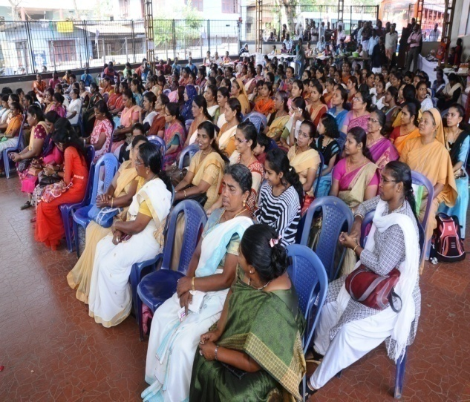
9.Women’s Day Programme
International Women’s day was observed and celebrated on March 8 at Thaliparamba Town Square. In association with the celebration programs an exhibition cum sales was also organized in which goods are sold out worth Rs. 35,000/- on that day. In the afternoon a women’s get together and exibision cum sale was also took place. The function was inaugurated by Smt. T.K. Shyamala Teacher, the Chair Person of Anthur Municipality. Smt. P. P.Latha, President, Thaliparamba Block Panchayat was the Chief Guest. The felicitation was by Mrs

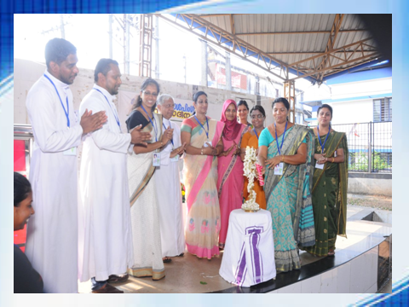

. Shibi Bernard and the programme was presided over by Very Rev. Fr. Devassy Erathara, the Vicar General of Diocese of Kannur. Prizes for the best stall was distributed by Smt. Ramani Remanand.

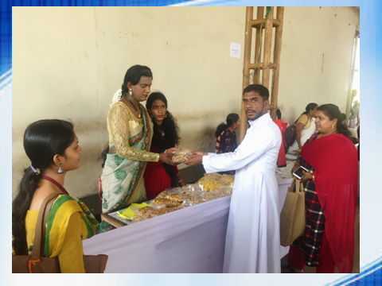
10.Special Group formation
This explains the effort taken by KAIROS to form special groups of people who are left behind from the mainstream, organizational activities like SHGs These groups include Widow groups, Senior citizens groups and Spinsters group. KAIROS conducted a special convention of the widows groups at Poovam, Embett, Bekkalam, Vellikkeel, Pattuvam & Pilatahra. We formed six groups of spinsters, seven groups of senior citizens

11. Micro finance
There were no accesses to the poor for resources that may support them to overcome their poverty. If anyone made them aware about the financial sources as well as the knowledge base accessible to them; they will produce extra ordinary results. To establish linkages to such resource centres, one of the means adopted by KAIROS was formation and strengthening of people’s groups in the form of SHGs and their federations at grass root level. In this endeavor, KAIROS has gone for miles and now there are 420 groups and 6 federations of such groups. They began to save their little earnings and achieved several targets of financial promotional activities. The money they saved are redistributed among the members through which they overcame their difficult situations.
12. Social Impact Study
The district collector Kannur has selected our organization to conduct social Impact Study as and when Land is to be acquired for developmental purposes. So far we have conducted study for Coast Guard Academy Irinavu, GAIL ,Mambaram Bridge, Kannur Airport,Koduvallr Railway Over Bridge and Thalassery –Valavupara Ist in Kannur District Our team studied the case very well and prepared the Social Impact Study Report and submitted the same to the District Collector in time. The report was well appreciated and as a result the District Collector ,Kozhikode also selected our institution to conduct such studies in that district also So far we have conducted two studies via Mangav road Junction and Kalluthan Kadavu Shopping complex in Kozhikode Disrict..

Conclusion
Capacity building of the people, empowers them, to take up the grievances and severe issues that negatively affects the development of the people and communities at the grass roots level. The capacity building programs and other awareness generation programs organized and conducted by KAIROS has achieved a certain range of development among the people. We are also committed to continue our capacity building programs in the coming years also.

People must have the opportunity to decide and determine their priorities. Many of the programs helped the people to do so. Most of the groups are taking off their destiny and are prepared themselves to go further. They also seek to gain control and access to resources. Economic empowerment is one of the means to empower the grass root level population. Enhancing women’s economic productivity at the grass root level, they need to be empowered, is an important strategy for improving the welfare of hundreds of households living below the poverty line. Our effort is to make the groups self reliant and self sufficient in terms of resources and access to resourceful institutions who are dedicated and committed to eradicate the cause of poverty.

We are thankfully remembering the agencies and institutions which were instrumental for the achievements of KAIROS during the reporting period. If it is not for their support and guidance, these achievements would not have been happened. We expect the similar support, cooperation and guidance from those partners in the coming years also.
A few words of gratitude for the whole team of KAIROS for having been instrumental for the transition taken place among the poor and marginalized, the new horizon of achievements in the socio economic development, and for the creation of the future generation who are ready to work for their own development.

Rev. Fr.Shaiju Peter.
Director - KAIROS

